SPARK RECIPES

Content:

1. Russian cuisine

2. British cuisine

3. American cuisine

Pan-cakes

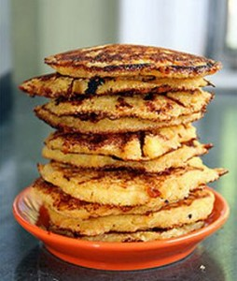

Ingredients:
1 egg, plus 2 extra egg whites
300 ml warm milk
10 g sugar
10 g yeast
225 g flour
vegetable oil for frying
butter for greasing pan-cakes

Method of Preparation:
1. To make a paste mix the yeast, milk, flour and sugar and egg yolk together in a large bowl.
2. Whisk the egg whites in a separate bowl until they form stiff peaks, then put them into the paste. Cover the bowl and set aside at room temperature for 20 — 30 minutes.
3. Heat a frying pan until medium hot, add a little vegetable oil and middle ladle of the blini mixture.
4. Cook the blini first on one side until golden-brown then turn it over and bake the other side then put blini onto a large flat plate and grease it with butter. Repeat with the remaining batter and keep the blini warm until ready to serve.
Bon appétit

Lesovaya Aleksandra

Stuffed Chicken

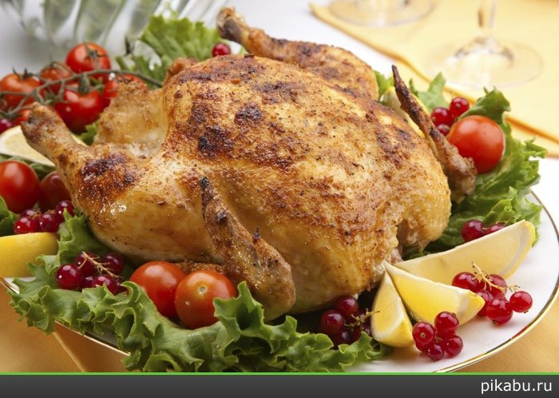

INGREDIENTS :
1chicken weighing
1 kg 400 with liver
200 g button mushrooms,
3 stalks parsley,
60 g butter
20 g bread
700 g potatoes,
salt
pepper

Preparation:
1. Clean and wash the mushrooms. Wash and dry parsley and remove leaves. Mince the chicken liver, parsley, chopped mushrooms and bread.
2. Preheat the oven at 220°C. Melt 15 g of butter in a frying pan and fry the stuffing for 2 minutes on a moderate heat.
3. Add salt and pepper and leave to cool.
4. Once the stuffing has cooled, stuff the chicken and sew it up (or plug with a ball of greaseproof paper).
5. Put the chicken in an oven dish, coat it with 15 g of butter and put in the oven. Cook for 15 minutes.
6. Peel and quarter the potatoes. When the chicken has cooked for 15 minutes, arrange the potatoes around it, adding knobs of butter, and leave to cook for a further 35 minutes.
Bon appétit!

Sbrodova.Irina

Salad Herring in Shuba (Russian dish)

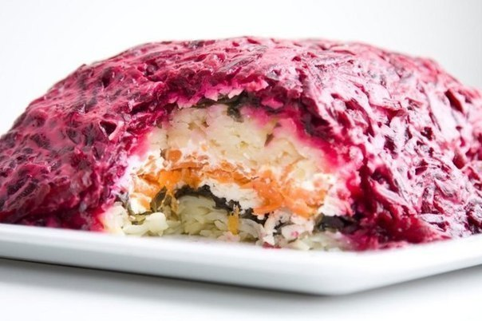

Ingredients:
- 2 thick salted herrings
- 5 potatoes
- 4 carrots
- 3 beets
- 1 small onion
- 300 g mayonnaise, parsley and dill

Method
1. Boil vegetables until they are fork tender.
2. Peel skin from herrings, cut them along the spine removing the bones. Cut
herring meat into little pieces checking for bones.
3. Grind potatoes, carrots and beets.
4. On a big round plate, place a layer of potatoes (whole portion), then spread mayonnaise evenly on top in a thin layer.
5. Then make a layer of beets using 1/2 of the beets, then a layer 1/2 of the carrots, 1/2 of the chopped onion and then– pieces of herring meat spreading mayonnaise evenly on top of each layer.
6. Place a layer of the remaining onion, a thin layer of mayonnaise, then a layer of remaining carrots, a thin layer of mayonnaise and finally the remaining beets.
7. On top pour the remaining mayonnaise.
8. Let it soaked overnight.
9. Decorate the dish with chopped parsley and dill.
10. Serve as a salad in its own right, or as an accompaniment to a main meal.
Julia Skripnik

Pancakes

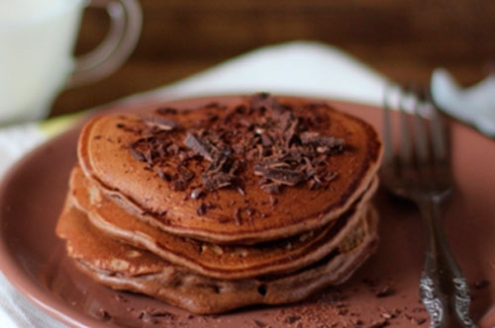

Ingredients:
1 1/2 cups all-purpose flour
3 1/2 teaspoons baking powder
1 teaspoon salt
1 tablespoon white sugar
1 1/4 cups milk
1 egg
3 tablespoons butter, melted

Directions
1. In a large bowl, sift together the flour, baking powder, salt and sugar.
Make a well in the center and pour in the milk, egg and melted butter; mix until smooth.
2. Heat a lightly oiled griddle or frying pan over medium high heat.
Pour or scoop the batter onto the griddle, using approximately 1/4 cup for each pancake.
Brown on both sides and serve hot.

Kseniaya Ponamareva

Traditional Christmas Pudding

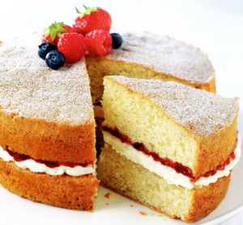

INGREDIENTS: l lb (500 g) raisins, l lb (500 g) currants, l lb (500 g) golden raisins, l lb (500 g) breadcrumbs, l lb (500 g) brown sugar, 8oz (230 g) suet, 4oz (100 g) mixed peel, 4oz (100 g) glace cherries chopped, 4oz (100 g) almonds chopped, 1 lemon (grate rind), 1 orange (grate rind), 1 carrot – grated, 1 apple – grated, 1 tsp mixed spice, 1 tbs sifted flour, pinch salt, 6-8 eggs, 10oz (280 g) stout (bottle) or dark beer (or 5 ozs (140 g) brandy & 5 ozs milk).

1. Chop glace cherries, almond.
2. Grate the carrot and the apple.
3. Grate lemon and orange rind.
4. Take your largest mixing bowl and Mix all the dry ingredients in it.
5. Beat the eggs lightly.
6. Add the beaten eggs and beer to the mixture.
7. Grease the bottom of a large bowl and press mixture into it.
8. Cover the top with wax paper (crimp it around the edges).
9. Put the bowl in a pan with water on stove for about 4 hours.
10. To prevent burning keep checking the water in pan.
11. Wrap the bowl well to keep it warm as long as possible.
12. Keep the pudding for one year to eat the next (not necessarily) :-D
13. Serve with cream, hot custard, or brandy sauce.
Bon appétit
Lesovaya Aleksandra

Champ
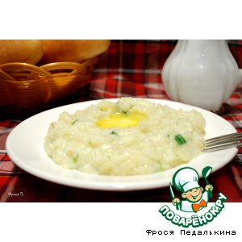

Ingredients
100g spring onions, cut into rings
150ml/¼ pint full-fat milk
900g mashing potatoes, such as King Edward or Maris Piper
85-100g/3-4oz butter
extra butter, for serving

Method
Put the spring onions and milk in a small pan and heat to boiling. Take off the heat and leave to infuse.
Boil whole potatoes in their skins for 30-40 min., or until tender (timing depends on their size). Drain and peel off the skins. Put the potatoes back in the pan, cover and gently heat for a min or two.
Remove from the heat and mash the potatoes with the butter until no lumps are left. Reheat the milk and the spring onions, then gradually beat this into the potatoes, mixing well with a wooden spoon to make the potatoes fluffy. Season well.
Serve on individual plates with a hollow in the centre of each serving in which you can put a big knob of butter. Diners then dip each forkful into the pool of melted butter before eating.

Julia Skripnik

Traditional Christmas Pudding

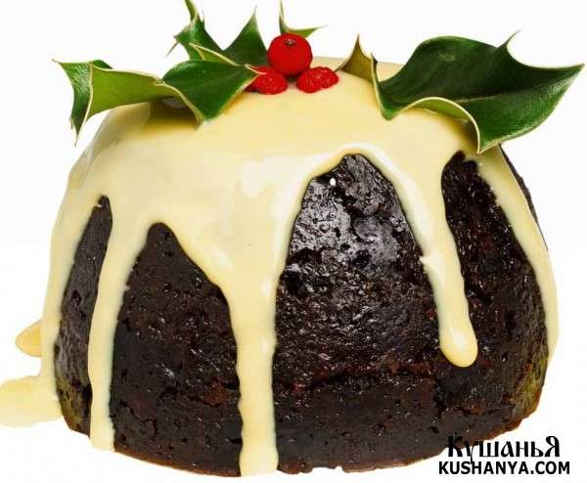

Ingredients:
I lb (500 g) raisins, I lb (500 g) currants, I lb (500 g) golden raisins, I lb (500 g) breadcrumbs, I lb (500 g) brown sugar, 8oz (230) suet, 4oz (100 g) mixed peel, 4oz (100 g) glace cherries chopped, 4oz (100 g) almonds chopped, 1 lemon (grate rind), 1 orange (grate rind), 1 carrot – grated, 1 apple – grated, 1 tsp mixed spice, 1 tbs sifted flour, pinch salt, 6-8 eggs, 10oz (280 g) stout (bottle) or dark beer (or 5 ozs (140 g) brandy and 5 ozs milk)

Preparation method:
1. Chop glace cherries, almond.
2. Grate the carrot and the apple.
3. Grate lemon and orange rind.
4. Take your largest mixing bowl and mix all the dry ingredients in it.
5. Beat the eggs lightly.
6. Add the beaten eggs and beer to the mixture.
7. Grease the bottom of a larger bowl and press mixture into it.
8. Cover the top with wax paper (crimp it around the edges.
9. Put the bowl in a pan with water on stove for about 4 hours.
10. To prevent burning keep checking the water in pan.
11. Wrap the bowl well to keep it warm as long as possible.
12. Keep the pudding for one year to eat the next (not necessarily).
13. Serve with cream, hot custard, or brandy sauce.

Bon appétit!

Shilo Margarita

Pumpkin – Ginger – Curry Soup

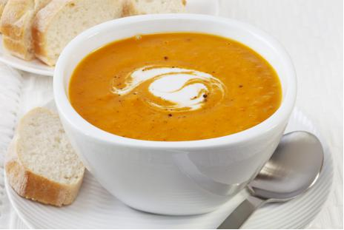

This Soup is wonderful on any day, but especially on a fall day having carved the pumpkin for Halloween.
The ginger and curry flavor with the pumpkin.
Ingredients:
Small onions, chopped-1th
tablespoon butter-1 th
fresh pumpkin, cubed- lb
cups chicken broth-2th
tablespoons fresh ginger- 2 th
chopped tablespoon curry -2th1 tablespoon turmerie

Preparation:
1. Melt the butter in a large pot and add onions, approx 5 minutes
2. App pumpkin, broth and ginger and cook over medium heat for approx 15 min until pumpkin is very tender.
3. Puree with have a smooth texture.
4. Add curry, turmeric and cream\ milk and heat through without boiling. Add salt to taste.
5. Serve with crusty bread.
Bon appétit!

Sbrodova.Irina

Traditional Christmas Pudding

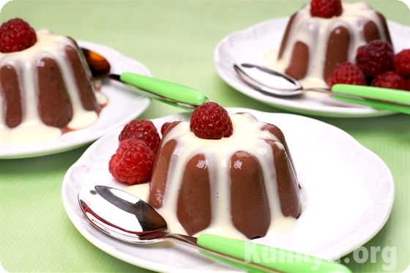

INGREDIENTS: l lb (500 g) raisins, l lb (500 g) currants, l lb (500 g) golden raisins, l lb (500 g) breadcrumbs, l lb (500 g) brown sugar, 8oz (230 g) suet, 4oz (100 g) mixed peel, 4oz (100 g) glace cherries chopped, 4oz (100 g) almonds chopped, 1 lemon (grate rind), 1 orange (grate rind), 1 carrot – grated, 1 apple – grated, 1 tsp mixed spice, 1 tbs sifted flour, pinch salt, 6-8 eggs, 10oz (280 g) stout (bottle) or dark beer (or 5 ozs (140 g) brandy & 5 ozs milk).
1. Chop glace cherries, almond.
2. Grate the carrot and the apple.
3. Grate lemon and orange rind.
4. Take your largest mixing bowl and Mix all the dry ingredients in it.
5. Beat the eggs lightly.
6. Add the beaten eggs and beer to the mixture.
7. Grease the bottom of a large bowl and press mixture into it.
8. Cover the top with wax paper (crimp it around the edges).
9. Put the bowl in a pan with water on stove for about 4 hours.
10. To prevent burning keep checking the water in pan.
11. Wrap the bowl well to keep it warm as long as possible.
12. Keep the pudding for one month.
13. Serve with cream, hot custard, or brandy sauce.

Kseniaya Ponamareva

Charlotte

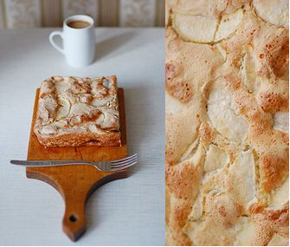

Ingredients:
Eggs -3th
cup sugar-1 th
cup flour-1th,
apples-3th.
Preparation: Wash and dry apples then cut each one into 4 wedges, core and slice. Set aside. In a large bowl mix thoroughly flour, sugar, and three eggs. Line baking form with parchment, grease to prevent sticking. Put apples in the form then pour batter. Bake at 180 degrees Celsius for 35-40 minutes til brown and wooden pick inserted comes out clean.
Bon appétit!
Sbrodova.Irina

Carrot Orange Cake 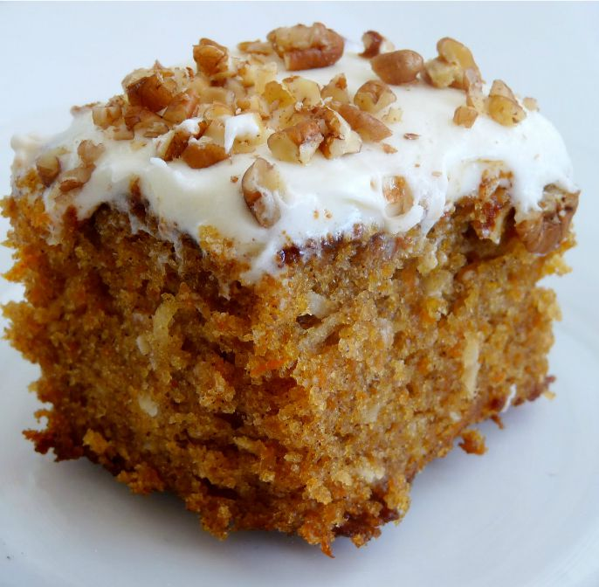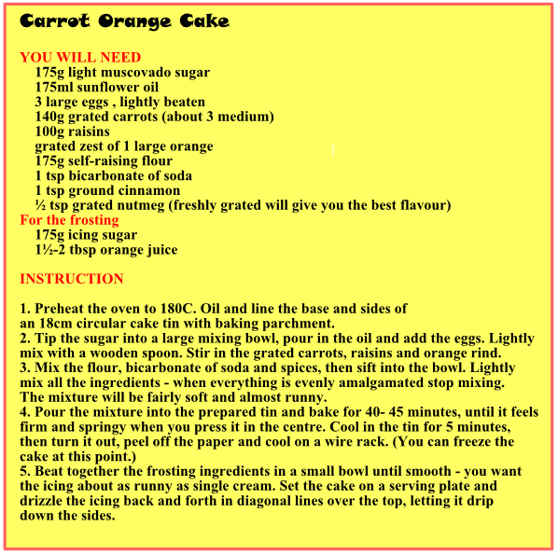

Bon appétit
Lesovaya Aleksandra

Вrownie

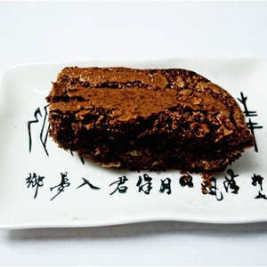

Ingredients
100 g unsweetened chocolate
1 stick (1/2 cup) unsalted butter, cut into bits
3/4 cup sifted all-purpose flour
1/2 teaspoon double-acting baking powder
Pinch salt
2 large eggs
1 1/4 cups sugar
1 teaspoon vanilla
1 cup chopped walnuts

Method

Butter and flour an baking pan and preheat the oven to 200 Cº.
In a small heavy saucepan melt the chocolate and butter over low heat, stirring until the mixture is smooth, and let the mixture cool completely. Into a bowl sift together the flour, baking powder, and salt. In a large bowl, using an electric mixer, beat the eggs. While still beating, add the sugar, a little at a time, and beat the mixture at high speed for 3 minutes, or until thick and pale.
Add in the chocolate mixture and the vanilla, and then add in the flour mixture, stirring until the mixture is blended well. Stir in the walnuts. Pour the batter into the baking pan, smoothing the top. Bake the brownies in the middle of the oven for 25 to 30 minutes, or until the brownie pulls away slightly from the sides of the pan, and a cake tester, inserted in the center, comes out with crumbs adhering to it. Let the brownies cool completely in the pan before cutting them into squares.

Julia Skripnik

Salad Herring under a fur coat.

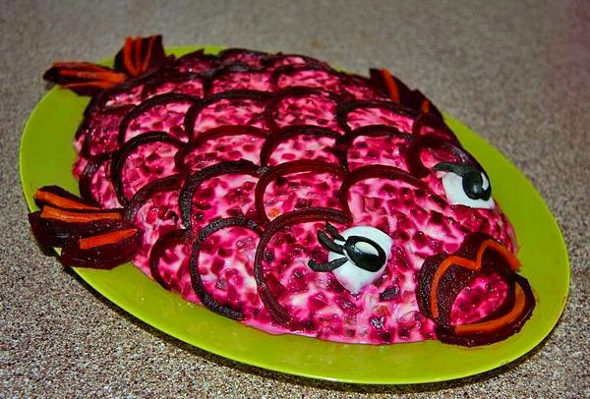

INGREDIENTS: 2 thick salted herrings, 5 potatoes, 4 carrots, 3 beets, 1 small onion, 300 g mayonnaise, parsley and dill
1. Boil vegetables until they are fork tender.
2. Peel skin from herrings, cut them along the spine removing the bones. Cut
herring meat into little pieces checking for bones.
3. Grind potatoes, carrots and beets.
4. On a big round plate, place a layer of potatoes (whole portion), then spread mayonnaise evenly on top in a thin layer.
5. Then make a layer of beets using 1/2 of the beets, then a layer 1/2 of the carrots, 1/2 of the chopped onion and then– pieces of herring meat spreading mayonnaise evenly on top of each layer.
6. Place a layer of the remaining onion, a thin layer of mayonnaise, then a layer of remaining carrots, a thin layer of mayonnaise and finally the remaining beets.
7. On top pour the remaining mayonnaise.
8. Let it soaked overnight.
9. Decorate the dish with chopped parsley and dill.
10.Serve as a salad in its own right, or as an accompaniment to a main meal.

Kseniaya Ponamareva

